Undergraduate Research Plan Report

Name: Elliot Lee

Major: AAE, CSE

Table of Contents

1. Temporary Abstract ...……………………………………………………………………………………………..Page 2

2. System Parts ………………………………………………………………………………………………..Page 2

3. System Diagram ………………………………………………………………………………………………..Page 2

4. Current State ………………………………………………………………………………………………..Page 3

5. Tentative Schedule ………………………………………………………………………………………………..Page 4

**1. Temporary Abstract**

In this undergraduate project, a simple embedded system is built as a form of drone, which enables human motion to interact with control loop. For a dual major student, aerospace and computer engineering, this project will foster myself to integrate the two fields so I can pursue corresponding area for the future graduate program.

The types of drone motion are confined to be three types: vertical, horizontal, and yaw motions. The environment is in-door without obstacles. Challenging aspects are that constructing a control loop which can reflect the inputs and feedbacks with least delay and that building a software for the system. For control loop, Arduino Uno (tentative) and micro sensors are used while c# (tentative) application will be developed for the operating software, which can analyze the input data and command output.

The drone, while the altitude is fixed, can maintain the distance from a human and follow him rectilinearly. I envision that I could pursue my graduate program based on this system so that I could implement not only sophisticated motion but also multi systems that autonomously communicate each other.

**2. System Parts**

Microsoft Kinect: A motion detect sensor, programmable with Microsoft Visual Studio.

ZBox: A computer for the software controlling Kinect and MUCs.

Arduino: A micro controller.

Hall effect sensor: A micro sensor to measure change of magnetic field. A small magnet is attached to a motor, and counts motor rotation; used as a rpm sensor.

Ultrasonic distance sensor: A distance sensor to measure the altitude of drone from the ground. Sensor range is from 3 cm to 400 cm.

Accelerometer: A micro sensor to measure the attitude of drone.

**3. System Diagram**

Hardware: Hard wares communicate with the corresponding parts as shown in Figure 1. Micro sensors are connected to MCU with wires. Kinect and MCUs are connected to main computer with USB cables.

Software: The software controlling the system is made of three threads to get inputs from a MCU and Kinect and send outputs to MCU simultaneously. (Figure 2)

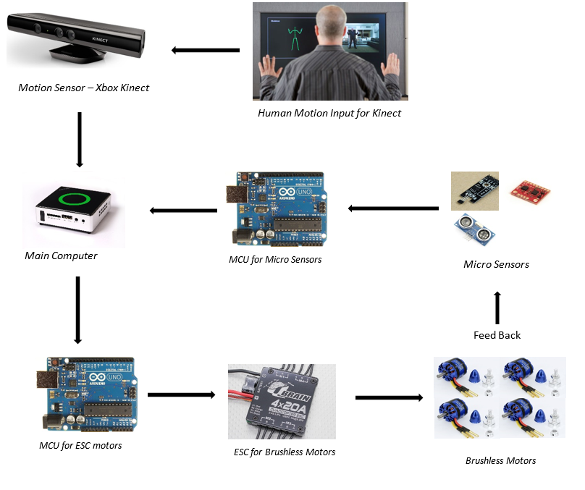

Figure 1 H/W Configuration

Thread 1:

- Kinect stream input

Thread 2:

- Sensor stream input

Main Thread

- Calculate output

- Send out via USB

Application

Figure 2 S/W Configuration

**4. Current Stage**

a) H/W

Current state of loop is to establish the connection between each micro sensors to a corresponding MCU. Simple loop to feedback a motor is being tested based on its RPM. Click Video Link

b) S/W

Example codes are testing to get stream image from Kinect.

**5. Tentative Schedule**

a) Project Length

Tentative project length is three years from now. The project length is estimated based on the expected graduation year.

b) Long-Term Schedule

First Year:

- Establishing a loop to balance attitude; simple motion to takeoff - hover - land.

- Kinect software development to get skeleton input of human

- Model for motion control

Second Year:

- Designing a new drone frame to mount the parts

- Building connection for H/W and S/W

- Adjusting loop

- Model for motion control

Third Year:

- Finalizing System

- Finalize Writing

- Presentation/Oral Defense

- Extra Events

c) Short-Term Schedule for 2014 - 2015

- Making Arduino library for each sensor and motor; for object-oriented programming.

- Developing lap-top application to monitor Arduino (matlab, c++, c#, or VB).

- Synchronizing the sensors and motors together via laptop application.

- Kinect software